Dear Parents/Guardians,
Our annual dress up day for Halloween will be held on Friday October 25th. Children may come to school dressed up in a Halloween costume. It might be a good idea to wear comfortable clothes underneath as the costumes can often be uncomfortable. We will have treats for the children on this day. We request a donation of €2 per child which can be given to your class teacher on or before this date.
This year the money raised will go to Fight For Fionn. All proceeds will be donated towards this worthy cause. The school will close at 12 noon on this day for our Halloween Midterm Break and will reopen on Monday November 4th.
Thanking you for your continued support,
___________________________
Brian Fitzgerald
Principal
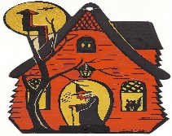
This Photo by Unknown Author is licensed under CC BY-NC

This Photo by Unknown Author is licensed under CC BY-NC-ND

