School Closures
Thursday 10th of October for staff training on the Primary Language Curriculum .
Halloween Break– Monday 28th October to Friday 1st November.

Upcoming events
A Welcoming Coffee Morning for Parents on Thursday 3rd of October at 9am in the school hall.
Maths Week – 14th – 18th October. More to follow….

School Newsletter September 2019
Raising Our Active Flag
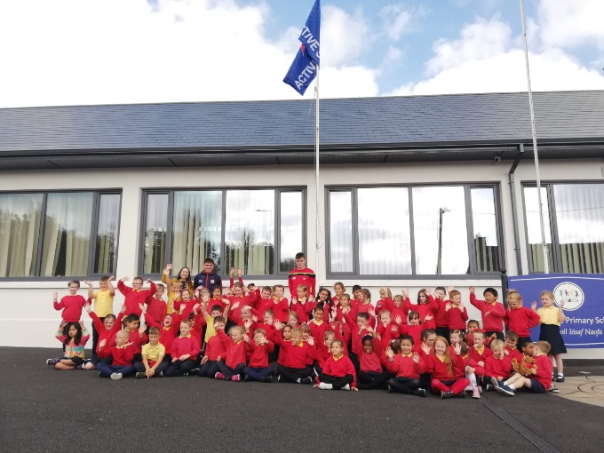
On Friday 20th of September we were delighted to welcome past pupil and hurling star, Darragh Fitzgibbon to our school to raise our Active School Flag. Darragh congratulated the pupils & staff for their efforts to secure the flag and spoke to the pupils about remaining active and fit through the various sports & clubs in our area. Special thanks to Ms Cott, Catherine Murphy & all the staff for their positive role in creating our active school.

School Website
Our new school website is now live. We are pleased to offer you this website as a communication tool. It will be one of the many ways in which we hope to interact with our school community and those seeking more information about the school. We invite you to visit at www.stjosephsinfants.ie. A special word of thanks to Ms Watson for all of her hard work in constructing & updating our website.

Green Flag
Our theme for this year is Global Citizenship - Energy. We will be revising the energy theme while looking at issues surrounding energy on a global scale. Ms Buckley & Ms Murphy will lead our Green School’s Programme this year.
Home School Community Liaison News
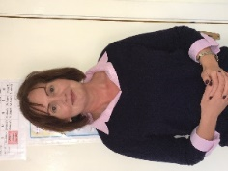
Ms Annett Hendrick is our new Home School Community Liaison Coordinator. The role of the HSCL is to work with and support parents/guardians in order to improve educational outcomes for children. This is achieved by promoting partnership and co-operation between home, school and the community to make sure that every child receives an equal opportunity for education in St. Joseph’s Infant School. The involvement of parents is key to the vision of the HSCL Scheme. Parents/guardians are provided with an opportunity to be involved in their child’s education through community initiatives, designed to support literacy, numeracy and positive engagement.
Home School Community Liaison Coordinator (HSCL) Contact Details:
Annett Hendrick Tel: 086 838 3248
Email: hsclstjosephs@eircom.net

Busy Bee Homework Club

The Busy Bees Club run by staff members provides a safe supportive environment within the school where children can do their homework after school on Monday to Thursday afternoons from 1.45pm to 2.40pm. Any enquiries to Ms Maeve Murphy, Coordinator.

Please note!
Our school premises both inside and out is a smoke, litter and gum free zone. Please respect this as we would like to retain our Green School image.

School Completion Programme

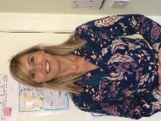

Ms. Louise Lee is our Project Worker with the School Completion Programme (SCP). The School Completion Programme offers our students extra support academically and socially in their time with us here in St. Josephs. The SCP is a targeted service for children who require additional support, This support is offered in a supportive, safe and non-judgemental environment. Louise has worked in St. Josephs for the past 9 years. Along with other members of our staff, SCP offer a daily targeted homework club and also take young students out to give some extra support during the school day. In the Summertime there is also a Summer programme provided to these young people that Louise takes throughout the year.
Louise Lee Tel: 087 6506624
Email: louise.lee@scp.ie

