Halloween Dress UP
Our annual dress up day for Halloween will be held on Friday October 25th. Children may come to school dressed up in a Halloween costume. €2 per child will be collected towards the Fight For Fionn campaign.
School Closures
The school will close at 12 noon on Friday for Halloween Break. The school will remain closed from Monday 28th October to Friday 1st November.
Upcoming events
English Classes for Parents/Guardians will commence on Wednesday 13th November at 9.15am in the school, subject to numbers (8+). For info please contact Annett Hendrick (086) 8383248.

We are delighted to get involved in this year’s Team Hope Shoebox Appeal.
Every year, with your help, the Christmas Shoebox Appeal sends thousands of gift-ﬁlled shoeboxes to children in Africa and Eastern Europe.

How to take part in 2019
Getting involved is simple! All you have to do is find an empty shoebox and wrap it in Christmas paper.
Then fill the shoebox with gifts for a boy or girl aged between 2 and 14, and bring it into school on or before Friday, November 8th.. Please include €4 in the box for postage.

After that we do the rest! We will send the boxes back to the Team Hope centre where teams of fantastic volunteers carefully check that each Shoebox gift meets custom and safety requirements before sealing them and loading them onto a truck to be sent on their way. Once they arrive, Team Hopes International Partners make sure your Christmas Shoebox gifts go directly to a child affected by poverty; for many it will be the only gift like this they’ll have ever received.
We wish to thank Sarah Janman for visiting & informing our pupils about the Christmas Shoebox Appeal.

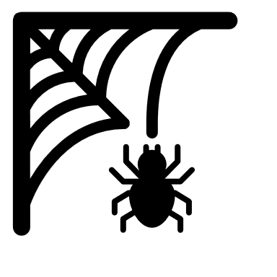
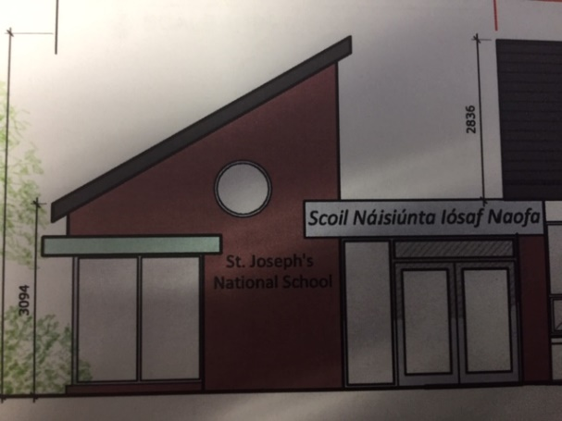
Construction of a New Entrance Lobby with Canopy , Adminstration & Principal Offices.

It is envisaged that the above works will be approved to go to tender in the coming weeks with a view to commencing works during the Summer Holidays 2020. Parents will be kept up to date on this timeframe through our monthly newsletters.

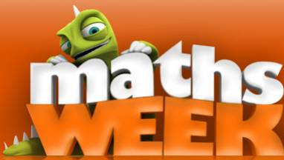
Maths Week took place in our school from 14th – 18th October. Maths Week Ireland promotes, awareness, appreciation and understanding of maths.
The children had great fun engaging in mathematical activities and games throughout the week. There was a fantastic buzz about school this week with lots of activities taking place. Classes were involved in card games, jigsaws, board games and maths trails & games out in the fresh air.
Thank you so much to our parents for coming in to take part and assist with classroom-based Maths activities with our 1st class pupils. Also, a huge thank you to all of our staff and in particular Mrs Cott who organised playground maths games which were a huge success!!!

Every Day Counts
During the month of November, the school will be taking part in the “Every School Day Counts” campaign to promote full attendance and punctuality in our school. This will include Art Competitions, 20 Day Challenge & further activities to raise awareness & encourage full attendance. More to follow……...

