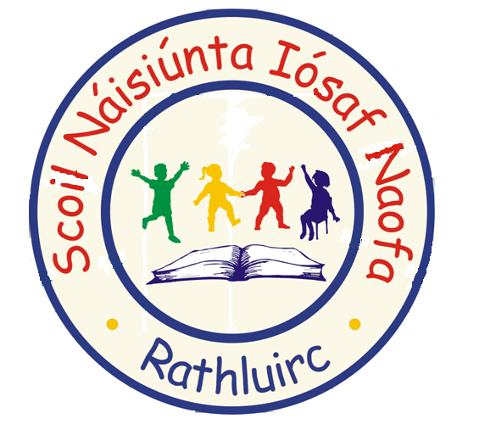
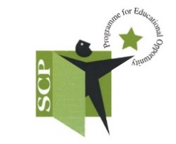
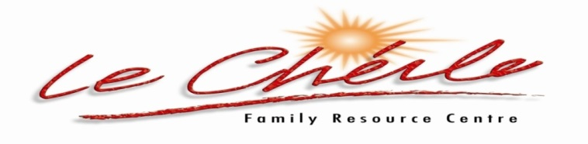

FREE “Early Years” programme for parents!

Sharing tips and ideas on how to manage your child’s behaviours

Venue: St Joseph’s Infant School, Charleville
Commencing: Tuesday January 21st Time: 9.15 – 11am

To ensure your place on this FREE course please text/call:
Annett Hendrick Tel: 086 8383248/Louise Lee Tel: 087 6506624

The “Early Years’ programme is an evidence based course promoting confidence, learning and positive behaviour in young children aged one to six years.
Using carefully selected DVD footage of parenting scenes & comments and stories from real parents and young children, the Early years programme is a fun and interactive programme for parents of young children.
The aim of this SIX week course is to:
- Support parents in their valuable role in their child’s life.
- Empower them to find solutions to childhood challenges and problems.
- Give skills in managing tantrums and misbehaviour in children.
- Shows them how to help children be more co-operative and keep rules.
Overall the aim of the programme is to help parents have close, connected relationships with their children, and to help them bring up emotionally secure, happy children who reach their full potential.

