School Closures
Mid-Term Break- February 20th & 21st.

Dancing Derek
A dance programme with Derek Long will commence in the school on Monday 17th February . This will consist of 6 dancing sessions for each class and a performance during the last term.

African Drumming
All classes will participate on Tuesday 11th February. Our pupils will be introduced to “the basic rhythmic concepts of West African and World percussion to schoolchildren through Drumming, Chanting, Singing, Body Percussion, Call and Response and storytelling”.

The school is currently enrolling for September 2020. Our enrolment forms are available at the school, local pre-schools and on our website www.stjosephinfants.ie. If you require any further information, please contact the school 063 89467 or stjosephscs@eircom.net. An information evening & school visit for our new pupils will be organised for the last term.

The school will be participating in Food Dudes Healthy Eating Programme
The Programme is comprised of positive role models, repeated tastings and rewards, and increases children’s consumption of fruit and vegetables in the long term. Healthy eating for children remains an important issue as 1 in 4 children in Ireland are overweight or obese.
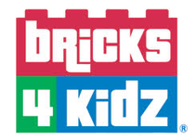

As part of Engineer’s Week 2020, Bricks4kidz will visit our school on Friday 6th & Monday 10th March. Brick4Kidz provide LEGO® Technic workshops which teach the principles of science, technology, engineering and maths through LEGO®.
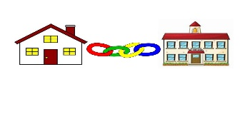
Home School Community Liaison

Free Early Years programme for parents.
Sharing tips and ideas on how to manage your child’s behaviour. On Tuesday – commenced on 21st January
-from 9.15-11.15am in the school.

English Classes for Parents/Guardians on Wednesdays at 9.15am ( beginners class) & 11.30am (intermediate class) in the school.

For info please contact Annett Hendrick (086) 8383248.

Board of Management 2019-2023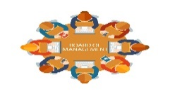
Our new Board of Management have taken up their positions for the 2019-2023 term. We welcome Fiona Lowe and Kathleen McEnery as new members. We are pleased to have Canon Donal O Mahony, Denis Waters, Eileen Matthews , Michael Moran and Michelle Barrett continuing in their roles. We would like to sincerely thank outgoing members, Sinéad Moloney and Bridget Biggane for their commitment, dedication and significant contribution to our school over the past four years. The new board are currently reviewing our Child Safeguarding Statement & Risk Assessment, Code of Behaviour and Health & Safety policies.

Parent Association
As you may be aware, our school does not have a Parent Association in place.
The Parent Association is the structure through which parents/guardians in a school can work together for the best possible education for their children.
The Parent Association works with the principal, staff and the board of management to build effective partnership of home and school.
A meeting will be held in the school on Thursday 27th February at 7pm regarding the setting up of a Parent Association in our school. Please come along-!!

