Room 4 Optional Homework (Ms O’ Flynn)
Hi Boys and Girls,
I hope you are all keeping well and enjoying the lovely sunshine that we are having. I hope you all had a lovely Easter. As you know the school is still closed until May 5th but I am still hoping to see you all again soon. Here is some work if you would like to do at home. If you would like to email me pictures of your work I would love to see them or if you have any questions do not hesitate to contact me. My email is emer.watson7@gmail.com. Looking forward to seeing you all soon hopefully,
Stay safe,
Ms. O’ Flynn

Monday April 20th
Planet Maths pg125
Spellings – ch words list 29 (Spellings attached at end of this document)
Put your spellings into sentences.
Wordwise p58 Read the story and write out all the words beginning with “s”
Oxford Owl – Pick a book online and read a few pages – its free to sign up (https://www.oxfordowl.co.uk/for-home/find-a-book/library-page/
Draw your favourite bird and write why you like it.

Tuesday April 21st
Planet Maths pg 126
Spellings -ch words list 30
Put spellings into sentences.
Wordwise pg 58 + 59
Reading Oxford Owl – continue with book

Wednesday April 22nd
Planet Maths pg 127
Spellings – ch words list 31
Put spellings into sentences.
Free writing – I got a new pet (where did you get it, what did you call it, who got it for you, what did you do to play with it, where did you take it and draw a picture)
Reading – Oxford Owl (read a few pages of a book)
Grow in Love pg 46

Thursday April 23rd
Planet Maths pg128
Spellings – list 32
Put spellings into sentences.
Writing – My News (a few sentences on what you do everyday)
Earthlinks pg 69
Reading – Oxford Owl (read a few pages)

Friday April 24th
Spelling Test on all spellings this week
Spelling worksheet attached below (can write answers into a copy)
Grow in Love pg 47
Planet Maths pg 129
Earthlinks pf 70
Reading – Oxford Owl – (read a few pages)

Monday April 27th
Planet Maths pg 130
Spellings – sh words list 33 (spelling sheet attached below)
Put spellings into sentences.
Wordwise pg 60
Reading – Oxford Owl (read a few pages)
Go outside and find different plants and animals that live around you. Draw them and write what they are.
Tuesday April 28th
Planet Maths pg 131
Spellings – sh words list 34
Put spellings into sentences.
Wordwise pg 61
Reading Oxford Owl – read a few pages
Grow in Love pg 48

Wednesday April 29th
Planet Maths 132
Spellings – sh words list 35
Put spellings into sentences
Free Writing – A trip to the beach (Who did you go with, where did you go, how did you go, what did you do there, when did you go there, what was your favourite part)
Reding – Oxford Owl – read a few pages

Thursday April 30th
Spellings – list 36
Put spellings into sentences
Maths – sheet attached (Mon/Tues – can write answers into your copy)
My News – write a few sentences on what you did this week and draw a picture
Grow in Love pg 49
Reading – Oxford Owl – read a few pages

Friday May 1st
Spelling Test on all spellings this week.
Spelling worksheet attached below (can write answers into a copy)
Maths – Sheet attached below (Wed/Thurs – can write answers into your copy)
Earthlinks pg 71

Some Extra work if you run out or want to do more:
I have attached another document with some fun things to do if you run out. It’s labelled Extra Work for first class. Enjoy

Spellings Monday 20th to Friday 24th
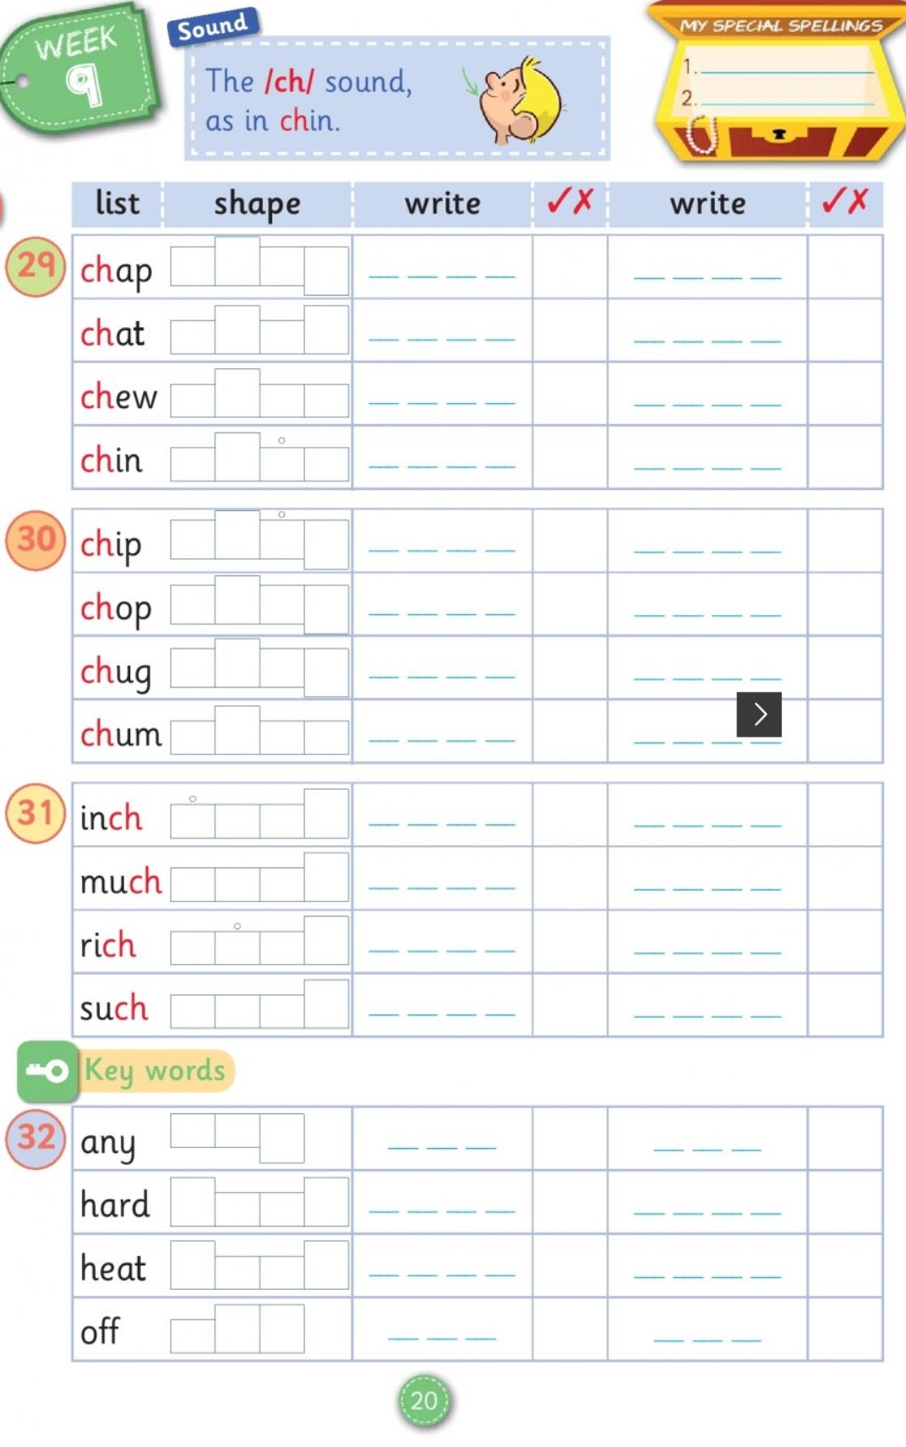

Worksheet Friday April 24th
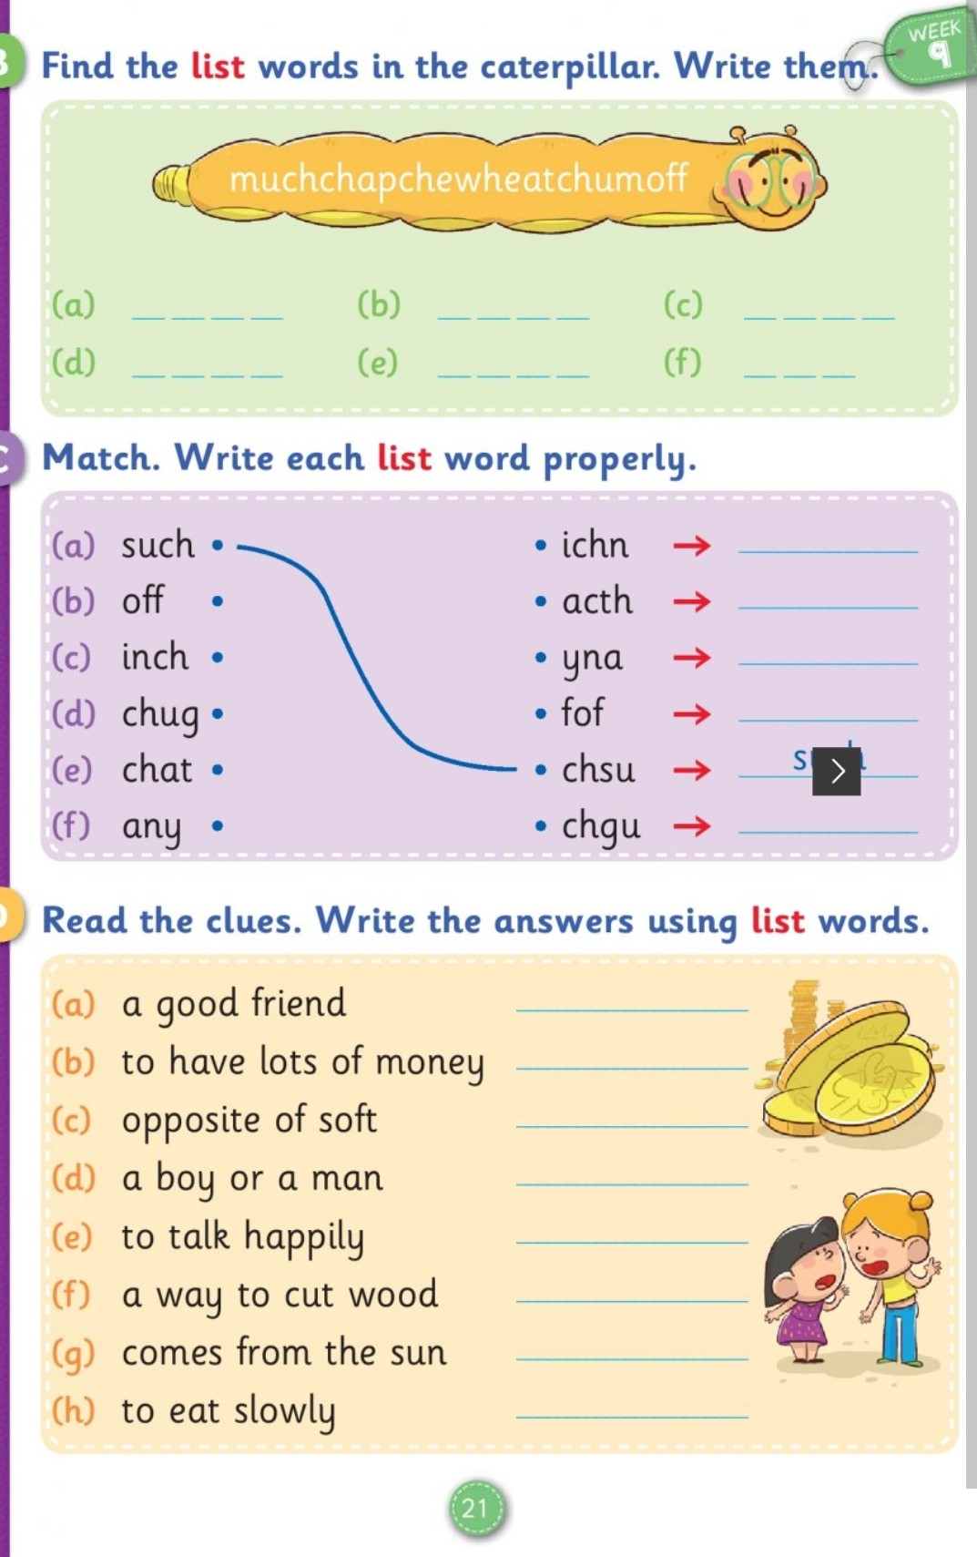
Spellings Monday 27th – Friday 1st
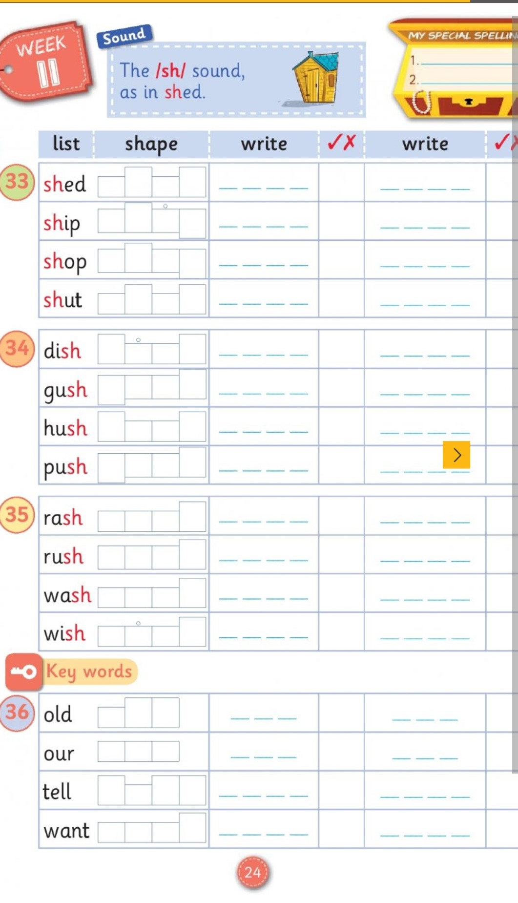
Thursday April 30th Maths worksheet
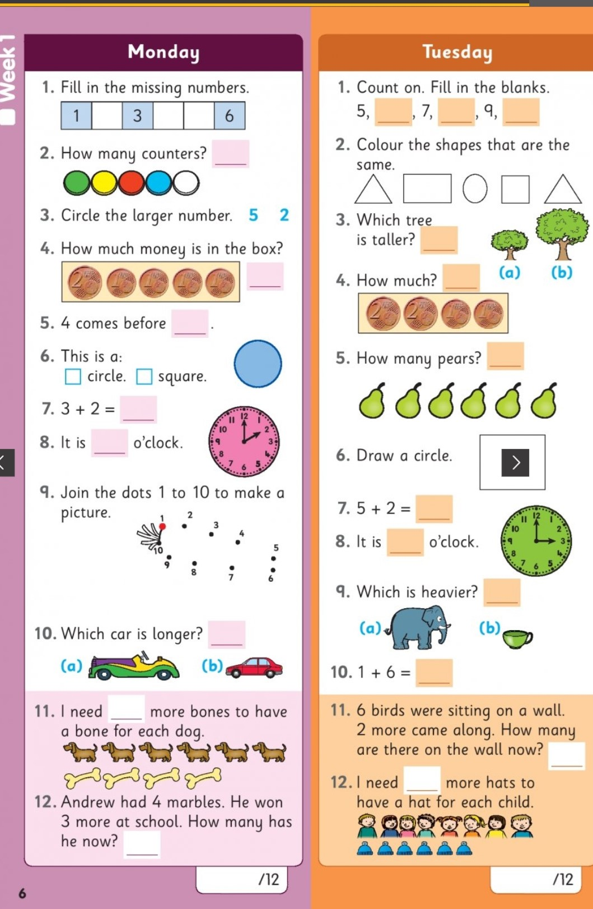

Worksheet Friday May 1st
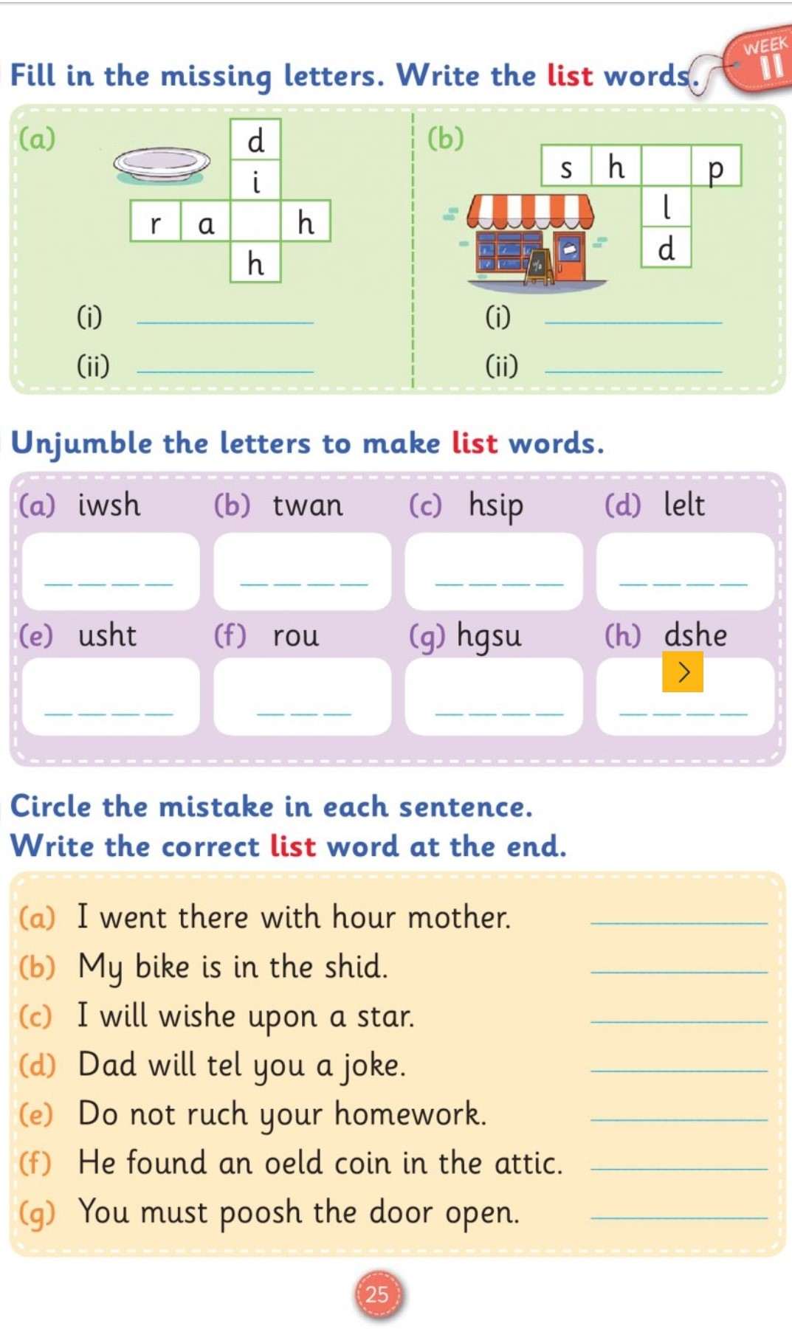
Friday May 1st – Maths Worksheet
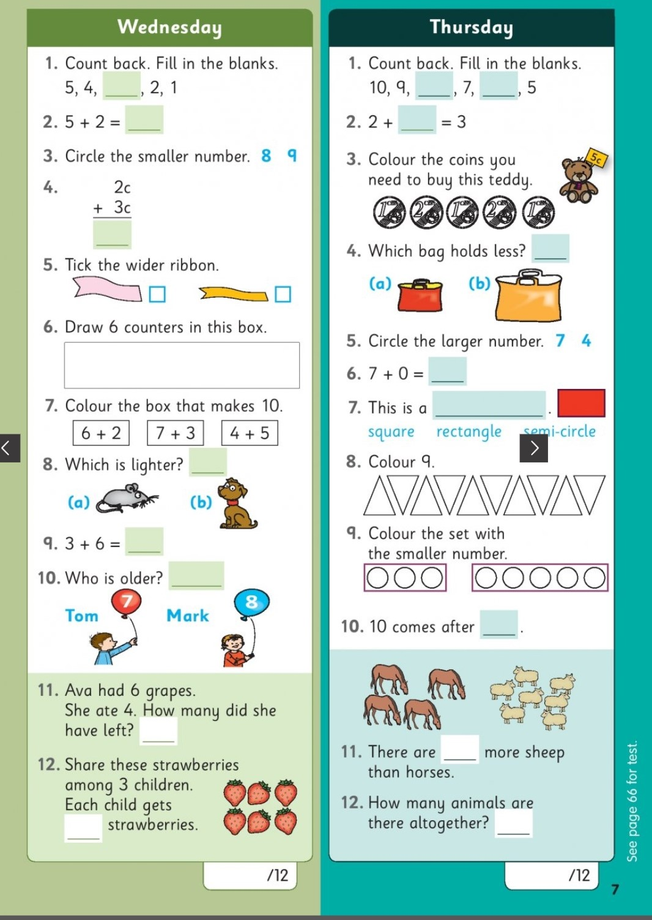
Irish
In school we use an interactive programme called Bua Na Cainte 1. The children interact with the conversations, songs, stories and play various games. This is available for you to download for free on a computer/laptop.
1. Go to www.edco.ie/bua
2. Select the file which suits your computer either computer or Mac.
3. Select the class level you require, First Class which is Bua na Cainte 1 and click on it to start a download of the file.
4. Once the download has completed, click on the file to install and follow the on-screen instructions.
5. A Bua na Cainte icon will appear on your desktop. Once you select this icon a login page will open where you will need to enter the details included below. The login details can be used for all class versions.
6. Username: trial
Password: trial.
Prior to the Lockdown we were working on the theme Sa Bhaile. The children may enjoy revisiting the previous themes, singing the songs, listening to the stories and playing the games. It is no problem if the children want to explore the remaining themes, whatever they enjoy.

