Room 7 Optional Homework (Mrs Cott and Ms Healy)
Hi Boys and Girls,
We hope you are all keeping well and enjoying the lovely sunshine that we are having. We hope you all had a lovely Easter. As you know the school is still closed until May 5th but we hope to see you all again soon. We really miss seeing your smiling faces every day! Here is some work if you would like to do at home. If you would like to email us pictures of your work we would love to see them or if you have any questions do not hesitate to contact us. Our email is leeniehealy82@gmail.com.
Looking forward to seeing you all soon hopefully, keep up the good work at home and doing your best to be as good as you can be for your parents.
Stay safe,
Mrs Cott and Ms Healy

Work starting Monday 20th April
Maths: Daily maths sheet
Planet Maths pages 120 -124
Spellings: Dolch word list 5 and 6
Monday: got; take; where; every
Tuesday: pretty; jump; green; four
Wednesday: away; old; by; their.
Reading: Dolch word lists 1-6, Read 2 lists each day.
Oxford Owl – Pick a book online and read a few pages – its free to sign up
Click into Free e-book library and pick any book
(https://www.oxfordowl.co.uk/for-home/find-a-book/library-page/

Read poem: Names (attached)
Starfall – www.starfall.com. Grade 1.
There are lots of different reading activities on starfall, maybe pick a different 1 each day to keep it fun. Learn to read; It’s fun to read;
I’m reading; Talking Library; and more phonics.
(If you find that grade 1 is too difficult, click into kindergarten. There are some
Lovely revision activities on this page that would be of benefit to all of the children,
Click on the picture of the mouse or the picture of the abc blocks and there are lots
More to explore too.
There are also some maths games on starfall too.)
Writing: I think it might be a nice idea to start keeping a short daily diary of what we do each day during our time at home. It will be a piece of history to look back on in time.
There is a lovely time capsule that you may like to do with your family to have in the future too.
We did this over the Easter holidays and we will open it in 10 year’s time! Imagine what life will be like then. I have attached the time capsule for you if you would like to do it.
Daily sentences.
Some writing ideas for this week are: My Easter holidays
I can describe ________(See picture attached Pick any topic eg crisps, cake, ice-cream)
My Bio poem (see picture attached)
Free writing – I got a new pet (where did you get it, what did you call it, who got it for you, what did you do to play with it, where did you take it and draw a picture)
Pick any topic from the WRITE sheet attached.
Write a few lines on the topic in your English copy and draw a picture.
Grow in Love: Page 44, 45 and 46
Earthlinks:Page 79 drawing plans. On a sheet, draw a plan of your bedroom, sitting room or kitchen. If you like you can draw a plan of your house and all of the rooms in your house as a project called 'My House Plans'
Page 80 and 81: Seasonal Changes: Summer

Art: Arthub4kids (type this into You Tube and pick something to draw – lots of lovely ideas)

Work starting Monday 27th April
Maths: Daily maths sheet
Planet Maths pages 125 - 129
Spellings: Dolch word list 6
Monday: here; saw; call; after
Tuesday: think; ran; let; help
Wednesday: make; going; sleep; brown.
Reading: Dolch word lists 1-6, Read 2 lists each day.
Oxford Owl – Pick a book online and read a few pages – its free to sign up
Click into Free e-book library and pick any book
(https://www.oxfordowl.co.uk/for-home/find-a-book/library-page/

Read poem: I’ll wear a smile (attached)
Starfall – www.starfall.com. Grade 1.
There are lots of different reading activities on starfall, maybe pick a different 1 each day to keep it fun. Learn to read; It’s fun to read;
I’m reading; Talking Library; and more phonics.
(If you find that grade 1 is too difficult, click into kindergarten. There are some
Lovely revision activities on this page that would be of benefit to all of the children,
Click on the picture of the mouse or the picture of the abc blocks and there are lots
More to explore too.
There are also some maths games on starfall too.)
Writing: Continue your daily diary.
Daily sentences.
Some writing ideas for this week are: My Weekend
I can describe ________(See picture attached Pick any topic eg crisps, cake, ice-cream)
I like poem (see picture attached)
Free Writing – A trip to the beach (Who did you go with, where did you go, how did you go, what did you do there, when did you go there, what was your favourite part and draw a picture)
Pick any topic from the WRITE sheet attached.
Write a few lines on the topic in your English copy and draw a picture.
Grow in Love: Page 47, 48 and 49
Earthlinks: Page 82 and 83: Experiment: Making Sounds and Heating and Cooling
Page 84: People at work
Art: Arthub4kids (type this into You Tube and pick something to draw – lots of lovely ideas)

Some extra fun bits to do if you run out or would like to do more:

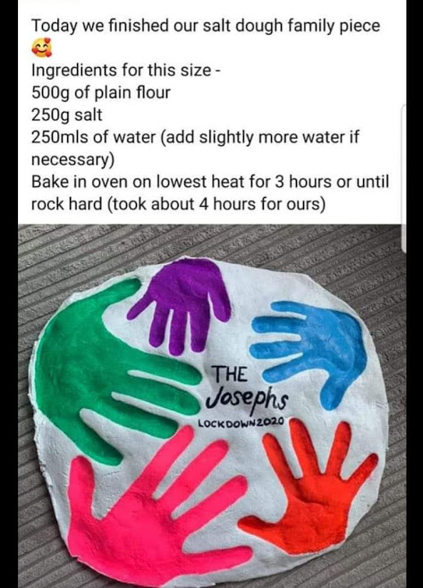

Playdough recipe
Did you know you can make playdough in next to no time from everyday ingredients found in your kitchen cupboards? Save money and involve the kids in this thrifty kitchen craft activity.
This super-easy playdough recipe is the perfect way to spend a rainy afternoon inside. It's quick enough to hold a young child's attention and you only need a few storecupboard ingredients. Little hands can play with the results straightaway, so there's immediate gratification for all involved!
Makes 1 coloured ball
Prep 10 minutes
You will need
- 8 tbsp plain flour
- 2 tbsp table salt
- 60ml warm water
- food colouring
- 1 tbsp vegetable oil
Method
1. Mix the flour and salt in a large bowl. In a separate bowl mix together the water, a few drops of food colouring and the oil.
2. Pour the coloured water into the flour mix and bring together with a spoon.
3. Dust a work surface with a little flour and turn out the dough. Knead together for a few minutes to form a smooth, pliable dough. If you want a more intense colour you can work in a few extra drops of food colouring.
4. Store in a plastic sandwich bag (squeeze out the air) in the fridge to keep it fresh. You can make a batch of colours and give away as kids’ party bag favours or hold a playdough party for your child’s next birthday

Make your own ice-cream with Zip-loc bags
Yes, it sounds dangerous and the potential for messes seems highly likely, but you’ll be surprised at the good, “clean” fun you’ll enjoy with your students when you make ice cream. The key to success is to plan smart and follow our simple instructions. The lesson possibilities for this one are nearly endless. Your class can explore the history of ice cream and dairy products, the chemistry of ice, salt and exothermic reactions, or use it an exercise in the scientific method: what if you make the following recipe without salt?
This recipe is enough for one student, so that each student can make their own.
1/2 cup milk
1/2 teaspoon vanilla
1 tablespoon sugar
4 cups crushed ice
4 tablespoons salt
2 quart size Zip-loc bags
1 gallon size Zip-loc freezer bag
a hand towel or gloves to keep fingers from freezing as well!
Mix the milk, vanilla and sugar together in one of the quart size bags. Seal tightly, allowing as little air to remain in the bag as possible. Too much air left inside may force the bag open during shaking. Place this bag inside the other quart size bag, again leaving as little air inside as possible and sealing well. By double-bagging, the risk of salt and ice leaking into the ice cream is minimized. Put the two bags inside the gallon size bag and fill the bag with ice, then sprinkle salt on top. Again let all the air escape and seal the bag. Wrap the bag in the towel or put your gloves on, and shake and massage the bag, making sure the ice surrounds the cream mixture. Five to eight minutes is adequate time for the mixture to freeze into ice cream.
Tips
Freezer bags work best because they are thicker and less likely to develop small holes, allowing the bags to leak. You can get away with using regular Zip-loc bags for the smaller quart sizes, because you are double-bagging. Especially if you plan to do this indoors, we strongly recommend using gallon size freezer bags.
Coffee Can Ice Cream
An alternative to the baggie method is to use coffee cans. The recipe is the same, and may be doubled or tripled because the coffee can can hold more liquid than the baggies. Put the mixture in a standard size coffee can and seal with the plastic lid, then place that can inside a larger “economy size” can (usually available from the teachers’ lounge or office). Pack the large can with ice and salt, and seal with the lid. Students can roll the can back and forth on the ground (outside – the condensation will drip) until the ice cream is set. The time required to set the mixture will vary depending on the number of servings in the can.
What does the salt do?
Just like we use salt on icy roads in the winter, salt mixed with ice in this case also causes the ice to melt. When salt comes into contact with ice, the freezing point of the ice is lowered. Water will normally freeze at 32 degrees F. A 10% salt solution freezes at 20 degrees F, and a 20% solution freezes at 2 degrees F. By lowering the temperature at which ice is frozen, we are able to create an environment in which the milk mixture can freeze at a temperature below 32 degrees F into ice cream.
Who invented ice cream?
Legend has it that the Roman emperor, Nero, discovered ice cream. Runners brought snow from the mountains to make the first ice cream. In 1846, Nancy Johnson invented the hand-cranked ice cream churn and ice cream surged in popularity. Then, in 1904, ice cream cones were invented at the St. Louis World Exposition. An ice cream vendor ran out of dishes and improvised by rolling up some waffles to make cones.

Drawing with Don Conroy
https://www.youtube.com/channel/UCo4dO9D4okn25M6mvfB02rQ

Cosmic Yoga Kids YouTube
https://www.youtube.com/user/CosmicKidsYoga

Dublin Zoo Webcam of Animals
https://www.dublinzoo.ie/animals/animal-webcams/

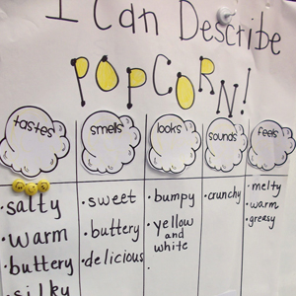

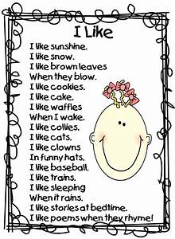
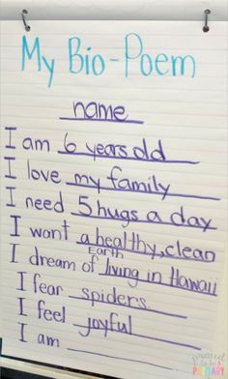

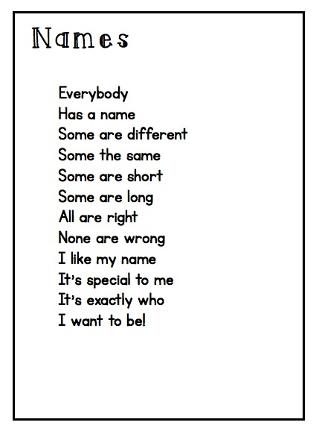

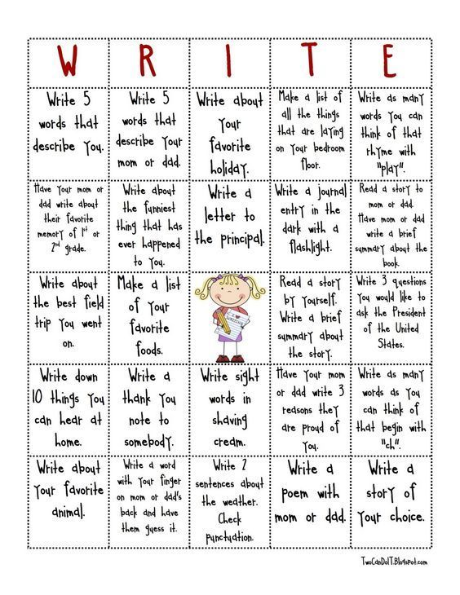

Irish
In school we use an interactive programme called Bua Na Cainte 1. The children interact with the conversations, songs, stories and play various games. This is available for you to download for free on a computer/laptop.
1. Go to www.edco.ie/bua
2. Select the file which suits your computer either computer or Mac.
3. Select the class level you require, First Class which is Bua na Cainte 1 and click on it to start a download of the file.
4. Once the download has completed, click on the file to install and follow the on-screen instructions.
5. A Bua na Cainte icon will appear on your desktop. Once you select this icon a login page will open where you will need to enter the details included below. The login details can be used for all class versions.
6. Username: trial
Password: trial.
Prior to the Lockdown we were working on the theme Sa Bhaile. The children may enjoy revisiting the previous themes, singing the songs, listening to the stories and playing the games. It is no problem if the children want to explore the remaining themes, whatever they enjoy.

