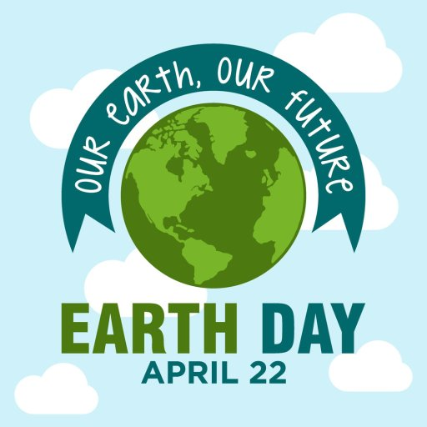
Hi Everyone,
Hope you are keeping safe and well and helping to save the planet while you are at home! Today the 22nd of April is Earth Day. Now I am sure lots of you are watching the RTE Home School at 11am in the morning did you know they also have a Home School Hub Extra which is the user generated kids takeover show on RTE2 every evening. Ahead of Earth Day they are asking kids to send in videos about how they are trying to save the planet and the environment. So if you would like to do this I have included some things you could say in your video below. Get an adult to help you, the phone should be sideways and videos should be around 20-30 seconds. Then when you are happy with your short video get an adult to send the video to their email which is homeschoolhubtv@gmail.com and send it to me maevemurphy005@gmail.com and Mr. Fitzgerald at stjosephsconventns@gmail.com. It would be so much fun to see someone from St. Joseph’s Infant School on the T.V today. There’s no pressure to enter, only do it if you would like to and you feel comfortable doing it. Get going if you can! Earth day is today!
I look forward to seeing what you create.
Regards
Ms. Murphy
Things you could say in your video:
Option 1: At home when its bright I switch off the light! I switch off the T.V when nobody is watching it and I take a quick shower instead of a bath. I make sure that the dishwasher and the washing machine are full before we turn them on. In school our Green Code is: THERE IS NO PLANET B SO SAVE ENERGY! (it might be a good idea to have footage of you switching a light off).
Option 2: When shopping we try to reduce the amount of plastic we bring home by using reusable shopping bags. I use reusable bottles, cups and lunchboxes and at home I recycle hard plastic, paper, newspapers, tins and magazines. ‘Reduce, Reuse, Recycle- These are words we know, we have to save our planet so we can live and grow. We might be only children, we have to try, you’ll see, we will save our planet, it starts with you and me!’ (You could sing this to the tune of incy wincy spider or just say it like a poem) then say;
Option 3: STOP THE DROP! At home I am always checking for dripping taps, if they are dripping they need to be fixed. I collect rainwater to water the garden and use a watering can instead of a hose to water the garden and I take quick showers instead of baths and when I’m brushing my teeth I never let the water run!
Option 4: In my Garden I have trees planted. Tree’s give us fresh air to breathe and give us fruit and vegetables to eat. They are home to many birds and other animals you may meet. So, it is so important to keep planting trees! Happy Earth Day.

