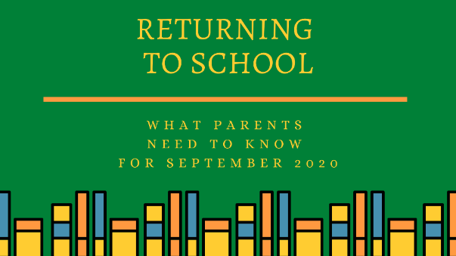

Dear parents & guardians.
We are looking forward to welcoming all of our pupils back to school at the end of August. This will need to be on a staggered basis initially to ensure our school can reopen safely. We will need all of us to work together and follow the guidelines to achieve this. Keep an eye on our school’s website and text messages in the coming days. We are busy preparing the school and the new policies and procedures for reopening on 27th of August. If you are not receiving text messages from us, check that our school has your correct contact details. Let us know if you have moved house, changed phone number or email address. You may also want to check that your emergency contact details are up to date.
Contents:
- What you can do to prepare
- Drop-off and collection
- Cleaning
- Physical Distancing
- Hand Hygiene
- Schoolbags and Lunches
- Communication with Teachers
- Teacher Absences
- Starting Junior Infants
- Children with Additional Needs
- Very high-risk pupils
- Suspected cases of COVID-19

What You Can Do to Prepare
- Practice washing hands properly, with soap, for 20 seconds. Make sure that your child also knows how to dry their hands thoroughly.
- Children should also know how to use hand-sanitizer correctly, and that it should not be ingested.
- Teach your child correct cough and sneeze etiquette. Cough or sneeze into a tissue, or into your elbow if you do not have a tissue. Put the tissue in the bin and wash your hands.
- Make sure that your child can INDEPENDENTLY open and close their lunchbox and bottle, their coat, and their shoes. Shoes with laces are not recommended for younger children!

Drop-off and Collection
- To reopen safely it is extremely important to limit interaction on arrival and departure from school.
- The school will have to have staggered drop-off and collection times initially.
- Each class will have their own entry/exit point and there will be a drop off/ collection area for parents to wait with social distancing marks on our yard. We will assign access points and entrances to specific classes. A video and map of the various entry/exit points will be uploaded to the website soon.
- Please wait in your car or delay arrival until your child’s drop off & collection times.
- The school gate will be opened at 8.50am. Access to the school yard before 8.50am is for staff only. If your allocated drop off time is 9.15 or 9.30 please do not arrive before this time.
- We ask that all parents/guardians wear a face covering when entering the school grounds. We would appreciate your cooperation with this request.
- Please leave the school grounds promptly after collecting your child and do not congregate outside the school or in the car park.

Pupils will return to school in the following order:

Thursday 27th August -
-Junior Infants only
Room 8 Mrs McCarthy’s class 9am to 11.20am
Room 9 Miss Casey’s class 9.15am to 11.35am
Room 10 Miss Murphy’s class 9.30am to 11.50am
------------------------------------------------------------------------------------
Friday 28th of August-
-Junior Infants -same times as on Thursday.

-Senior Infants will return to school today.
Room 5 Ms Sheahan’s class 9am to 12noon
Room 4 Ms Shinnick’s class 9.15am to 12.15pm
Room 3 Ms Hartnett’s class 9.30am to 12.30pm
---------------------------------------------------------------------------
Monday 31st of August-
-Junior Infants –same times as on Thursday & Friday

-Senior Infants- same times as on Friday.

-1st Class will return to school today.
Room 6 Ms McAuliffe’s class- 9am- 12.50pm
Room 7 Ms Healy’s & Mrs Cott’s class 9.15am - 1.05pm
------------------------------------------------------------------------------------
On Tuesday 1st September all classes will start school at 9am.

Junior Infants 9am – 12 noon ( 1.30pm from Wednesday 9th onwards)

Senior Infants 9am – 1.30pm (older siblings in 1st class will leave at this time)

1st Class 9am- 1.45pm

Cleaning
- Cleaning in our school will be increased considerably. Schools have been given a budget for the extra cleaning and cleaning materials required.
- Each classroom will be cleaned daily.
- Resources will be provided for children individually where possible, or shared with their ‘pod’. Resources that are shared between classes will be cleaned between use.
- Books, toys and resources will be cleaned regularly or quarantined for 72 hours before being reused.

Physical Distancing
- Children from Junior Infants to 2nd Class are not required to physical distance. However, we will make every effort to arrange smaller groups within classrooms.
- Each class will be a ‘Bubble’. Contact between bubbles will be extremely limited and break times will be staggered.
- Classes will be divided into groups, or ‘Pods’. These children will sit, work and play together. They will stay in the same pod for a number of weeks
- Staff will try to maintain physical distance from children when they can, and will wear face coverings and other PPE when needed.

Hand Hygiene
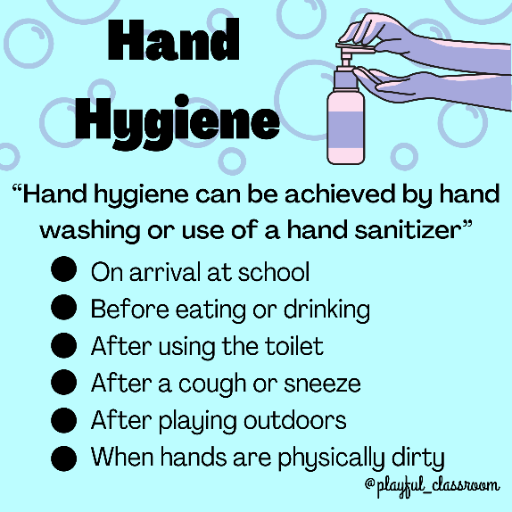
- Children will perform hand hygiene regularly during the school day:
  - on arrival at school
  - before eating or drinking
  - after using the toilet
  - after a cough or sneeze
  - after playing outdoors
  - when hands are physically dirty
- Hand sanitizer dispensers will be installed throughout the school.
- Children are not required to supply hand sanitizer or any other hand hygiene products.

Schoolbags and Lunches
- The government have not given any guidelines regarding these items but a common-sense approach should be followed.
- Ensure that your child does not have any unnecessary items such as toys in their schoolbag.
- Choose lunchboxes and bottles that are easy to clean, as they will need to be cleaned frequently.
- The school will provide a pencil case with pencils, rubber, topper & crayons for every individual child. This pencil case will remain in the school.

Communication with Teachers
- Parents will not be permitted to enter the school building.
- Appointments may be made to visit the school for essential purposes. A contact tracing log will need to be filled out for each visit.
- This does not mean that you will be unable to communicate with your child’s teacher. You can communicate with them via the traditional methods such as phone calls & emails.
- School phone numbers – Office (063) 89467 Mr Fitzgerald (086) 0560135 Annett Hendrick (086) 8383248

Teacher Absences
- The Irish National Teachers’ Organisation have put pressure on the Department of Education on the issue of substitute teachers. Supply panel clusters of substitute teachers are being set up to increase substitute availability.
- If the school is unable to secure a substitute teacher, the school may use a non-mainstream teacher to cover the absence. (This includes Special Education Teachers and administrative principals).
- Every effort will be made to avoid a class being split between other classes.

Starting Junior Infants
- Unfortunately, parents will not be permitted to enter the school classrooms with their child on the first day of school (or on subsequent days).
- Rest assured, the Junior Infant teachers and other school staff will do their best to make sure that every child feels happy and safe at school.
- The benefits of play are well-documented, and infant teachers are very aware of this. Lots of time will be spent playing and listening to stories. The number one priority for the first few months of school will be the children’s well-being.

Children with Additional Needs
- The Special Education Team in our school will make sure that your child’s needs are catered for to the best of their ability.
- Special Education Teachers may be required to cover for mainstream teachers in the case of their absence and a substitute teacher is not available. This may mean that your child may have reduced support at times, but the school will do their best to avoid this happening.

Very high-risk Pupils
We will work very closely with parents in determining whether it will be possible or not for high risk pupils to attend school. Very high risk pupils may not be able to attend school. These pupils will receive appropriate support to engage with learning. Ongoing connection with their classmates and school community will be ensured.
The list of people in the very high risk group is available at https://www2.hse.ie/conditions/coronavirus/people-at-higher-risk.html

Suspected Cases of COVID-19
Symptoms of COVID-19
  - High temperature
  - Cough
  - Shortness of Breath or Difficulty Breathing
  - Loss of smell or taste, or distortion of taste
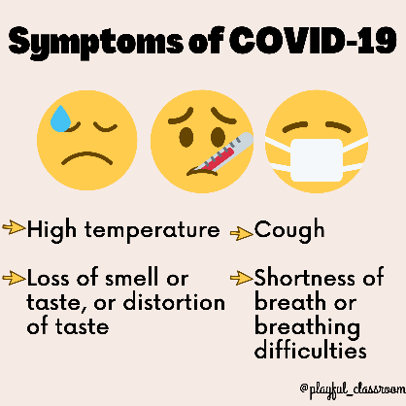
- Children should NOT ATTEND school if they are unwell or if any members of their household are unwell with symptoms of COVID-19.
- If any pupil becomes unwell while at school, they will be brought to an isolation room and given a mask to wear. Parents will be contacted to collect their child as soon as possible.
- The HSE will inform any parents of children who have come into close contact with a diagnosed case.

