The ultimate list of free educational resources for parents
We asked primary school teachers for their top website recommendations to help you survive the next few weeks of homeschooling
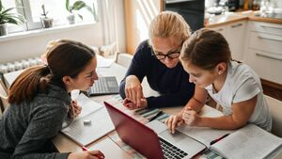
The Government's latest announcement means another month of at home schooling. Picture: iStock
THU, 07 JAN, 2021 - 15:55
MARTHA BRENNAN
With schools set to stay closed for the remainder of the month, many parents are facing another bout of homeschooling. While the idea may seem daunting to some, there are plenty of educational resources available online to help keep children entertained during lockdown.
Teachers are already starting to work on at-home teaching programmes and provisions have been made by the Department of Education for students who don’t have access to the internet.
However, as the Ombudsman for Children Dr Niall Niall Muldoon said earlier this week: “Education is about more than learning, it is about developing personalities, talents, and abilities of children to reach their greatest potential while also facilitating mental health, play, and recreation.”
So we asked primary school teachers for their top recommendations for additional resources parents can use to help teach children across a range of subjects, from Irish to art and SPHE.
“There is an abundance of tools and online websites available that are educational and will keep children engaged,” says Cork-based primary school teacher Aoife O’Sullivan.
"A lot of teachers will be administering their own homework over the next few weeks but it’s great to have extra tools available on laptops and iPads to keep children entertained. Most are free and are interactive and fun for children as well. They’re great for teaching kids without making them feel like they’re in school."
When it comes to primary learning the Department of Education recommends that parents seek advice from their schools and class teachers first and foremost as they are best placed to advise on resources based on the particular learning needs of the children.
“There are lots of interactive connection platforms, like Seesaw or Padlet, where teachers put up work for children and talk to parents," O'Sullivan says. "It’s under the discretion of the school what platforms they use but if parents do need to reach out to teachers they can do so through such platforms. We’re still here and we want to make sure that our students are learning during these closures.”
The top free educational resource websites for primary school pupils
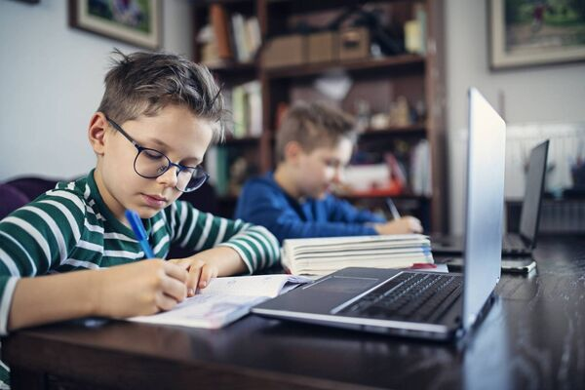Online activities can help keep kids occupied over the next few weeks.
Seomra Ranga
Seomra Ranga was created by a Dublin primary school teacher in 2007 and features a range of free activities and resources, such as flashcards, poetry books, and educational bingo games.
www.seomraranga.com
Khan Academy
Khan Academy is an international website that is highly recommended by many teachers and parents. Courses are broken up into multiple subjects and classes, helping you to create a personalised educational course for your child.
www.khanacademy.org
Education.com
Education.com’s Learning Library contains a plethora of fun worksheets for primary level children, such as word searches, colouring books and writing exercises.
www.education.com/resources
RTÉ Learn
RTÉ Learn contains tonnes of different activities for children as well as access to episodes of last year’s Home School Hub.
www.rte.ie/learn
Maths
Top Marks
Top Marks splits activities into age groups and levels ranging from the ‘Teddy Numbers’ game that helps toddlers learn to count to two-minute subtraction challenges for older children.
www.topmarks.co.uk
Tablestest.com
Help your children learn their times tables by testing them on tablestest.com
www.tablestest.com
Prodigy.com
Kids can play the Prodigy maths game for free on prodigy.com to help them learn equations in a fun and interactive way.
www.prodigygame.com
SESE (History, Geography and Science)
National Geographic Kids
You can find interactive games, videos, and fact sheets about everything from animals to the world's wonders and climate change on National Geographic’s dedicated kids' website.
www.kids.nationalgeographic.com
BBC Teach
BBC Teach provides educational videos for children on topics ranging from nature to drama but teachers particularly like the website for its historical content.
www.bbc.co.uk/teach
History of Cork
Any rebel parent wanting to teach their kids a little more about the rich history of Cork can lead them to this website for a crash course aimed at 5th and 6th class students.
www.askaboutireland.ie/learning-zone
Virtual exhibitions
Take your child on a virtual field trip with the National Museum of Ireland and London Zoo's free online exhibits.
NASA STEM Engagement
NASA has created a website dedicated to teaching children about science, technology, and space with tons of content for every age.
www.nasa.gov/stem
Frugal Fun
Frugal Fun was created by an American mom who has been homeschooling her five children since long before Covid hit. Check out her Lego activities and STEM content for fun educational games.
www.frugalfun4boys.com
Ask About Ireland
Learn everything you need to know about Irish history and geography from Ask About Irelands’ learning zone. Content is filtered by class and subjects.
www.askaboutireland.ie
Irish
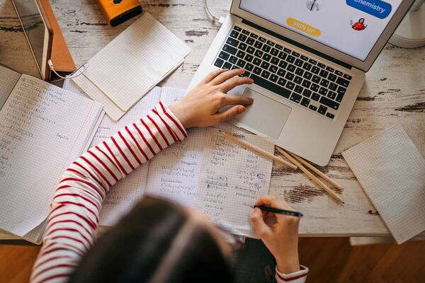Homeschooling doesn't have to be boring, once lessons are done log online for some extra educational games and activities. Picture: iStock
Teachers love the Séideán Sí website for extra Irish vocabulary lessons for kids. You can choose your dialect and child’s class to find specific games and activities.
www.seideansi.ie
Cúla 4 ar Scoil
While the Department of Education doesn’t endorse any websites in particular, a spokesperson did recommend TG4’s Cúla 4 ar Scoil programme, which is available on TG4 Player online.
“The programmes follow a specific theme for each series of lessons. Each lesson has specific educational outcomes, and are presented in an engaging and entertaining style,” the spokesperson says. “In particular Cúla 4 ar Scoil offers an opportunity to hear a rich range of Irish language dialects from various Gaeltacht areas.”
www.cula4.com/en
Gaelige le Chéile
Gaelige le Chéile was created with the aim of making learning Irish fun and its resources are a great way to make Irish a part of children’s daily lives during lockdown.
www.gaeilgelecheile.weebly.com
The website of An Chomhairle um Oideachas Gaeltachta agus Gaelscolaíochta also has links to many educational resources to support children’s Irish learning.
Music and Art
Songs in Irish
Songs in Irish has over 600 Irish language songs in its online database with an English translation and Youtube link for each. Guitar chords are also provided for some songs.
www.songsinirish.com
Kidzbop
Kidzbop’s Youtube page has hundreds of dance and singalong videos for children.
www.youtube.com
Cbeebies
Cbeebies provides a host of quick and easy craft activities for kids on its website.
www.global.cbeebies.com/make-and-colour
Kids Activities Blog
Kidsactivitesblog.com is a godsend for parents looking for child-friendly activities. Check out the 5-minute craft and drama activity sections of the website.
www.kidsactivitiesblog.com
Red Ted Art
Look no further than Red Ted Art for all of your art class needs for children.
www.redtedart.com
Beat by Beat Press
Discover the world of musicals with Beat by Beat Press in an interactive way to help with drama and music teaching.
www.bbbpress.com
English
Collins Connect
Access Collins’ reading resources and activities, no sign-up required, on the website’s school portal.
www.connect.collins.co.uk
Knoword
Knoword has classroom vocabulary games and quizzes on its website to help enhance students’ knowledge.
www.playknoword.com
Handwriting Practice
You can find worksheets to help students learning to write on handwritingpractice.net
Oxford Owl
Oxford Owl has an extensive free e-book library as well as reading activities for all ages and phonics lessons available on its website.
www.home.oxfordowl.co.uk
Audible Stories
For those who struggle to sit down and read a book, Amazon’s Audible platform has a library of free audiobooks of all genres and levels for kids available on its website and app.
www.stories.audible.com
SPHE and Wellness
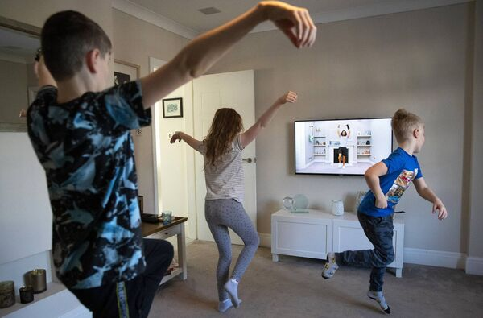Fitness coaches, such as Joe Wicks, are providing free PE classes online. Picture: Alex Livesey Danehouse, Getty Images.
The Great Isolation Activity Book
The Irish created Great Isolation Activity Book can be downloaded and printed out for free online. The book contains pages of fun and creative activities for children as well as useful lessons in SPHE and wellbeing.
Access the pdf here.
PE videos
There are loads of videos online offering free PE lessons for children to make sure they stay active during lockdown. The teachers we spoke to particularly liked fitness guru The Body Coach Joe Wick’s PE videos which are aimed young students.
RTÉ Jr also started to create 10 minute PE videos for kids to help them stay active when Covid struck. You can access the videos here when the kids start bouncing off the walls and need to burn some energy.
Adriene Mishler, or Yoga with Adriene as she is known to her millions of subscribers, also has a PE series available online for parents wishing to introduce their children to yoga.
Cooking for kids
Why not get your kids involved in the kitchen and teach them some easy (supervised) cooking recipes when they can’t face sitting in front of a screen anymore?
BBC goodfood has a section of recipes for children online and Cbeebies has created a Youtube playlist of instructional videos for young chefs.
To learn more about the guidance available for supporting children during school closures see www.education.ie/covid19.
More information can also be found from the National Parents Council, One Family Ireland, the National Council for Special Education and the National Council for Curriculum and Assessment.

