EAL Policy

Introductory Statement:
The purpose of this policy is to provide guidelines to school staff on the delivery of English as an Additional Language (EAL) in St Joseph’s Convent NS. This policy will provide a basis of consistency and quality while allowing for flexibility in the delivery of EAL service. The aim of our EAL policy is to ensure that pupils develop the competence to use English confidently as a means of learning across the range of curriculum areas. St Joseph’s Convent NS acknowledges the right of children to communicate and socialise in the language of their home.
Given that the number of pupils requiring EAL support has increased year on year, it has become necessary to revise our EAL policy regularly to address the increasing needs of our pupils.

Rationale:
In St Joseph’s Convent NS, we have a significant number of children who speak languages other than English and come from diverse cultural backgrounds. We recognise that the presence of these children in our classrooms enhances our teaching and learning experiences.
The variety and diversity of the languages that the children bring to the classroom and to our school is respected and celebrated. The EAL service enables the students whose primary language or language of the home is other than English, to develop their individual potential and integrate fully in an inclusive school. This accords with the Department of Education’s Wellbeing Policy Statement and framework for Practice (2019) which emphasises “the need for children to experience a sense of belonging and to feel safe, connected and supported in school”.

Aims and Objectives:
In St Joseph’s Convent NS, we are committed to providing appropriate provision of teaching and resources for pupils for whom English is an additional language. This policy aims to raise awareness and to support planning, organisation, teaching and assessment procedures and the use of resources and strategies to meet the needs of pupils who have English as an additional language (EAL), therefore raising pupils’ achievement and aspirations.

We aim to:
- integrate EAL pupils as quickly as possible into all mainstream learning and activities within the school
- provide our EAL pupils with a safe, welcoming, nurturing environment where they are accepted, valued and encouraged to participate
- identify individual EAL learner's needs, respond to them and recognise skills already required.
- develop pupils’ confidence and self-esteem and encourage creativity.
- develop whole school staff expertise to ensure that all EAL pupils attain levels of achievement appropriate to their intellectual abilities.

- strive towards children’s progress in English in both BICS and CALP through the integration of EAL programmes with the Primary language curriculum and the new Primary curriculum.
- be proactive in removing barriers that stand in the way of our EAL pupils’ learning and success.
- meet our responsibilities to EAL pupils by ensuring equal access to the curriculum and the achievement of their educational potential.
- develop monitoring, evaluating and review systems.
- promote effective home school links and increase parental involvement in school activities.

Organization of teachers:
Mainstream class teachers and any additional language support teachers in the school have a role in progressing the language learning needs of children for whom English is an Additional Language (EAL).
In St. Joseph’s Convent NS, EAL teachers work as part of the EAL Support Team and in close collaboration with the class teacher. They provide support and reinforcement to the pupil’s language learning through a mixture of in class support and withdrawal groups based on the needs of the school.
When timetabling, priority will be given to those children with the lowest English language proficiency. If children are being withdrawn for language support every effort will be made to match children to a peer group of similar age and level of language proficiency.

Roles and Responsibilites:
This policy is coordinated by the EAL coordinator in consultation with the principal and the staff. Collaboration between all school staff is essential for fostering an inclusive learning environment that supports EAL learners.
- Every effort will be made to help pupils settle socially and gain confidence into their new class and environment
- A “buddy” will be appointed to help all new pupils to settle in and experience friendships in their new school environment.
- Teachers will ensure that the newly arrived pupil, at the early stages of learning English sits near the front of the class so that they have immediate accessibility to the class teacher’s facial gestures and body language and interactive technology.
- At the early stages of learning English, the child is seated between good language role models (not necessarily the buddies) so that they are listening to good examples of spoken language structures
- Respect the pupil’s silent period in which he or she will be observing and listening to others. Remember that active listening is an integral part of learning.
- The class teacher and EAL Teacher will ensure that newly arrived pupils can understand basic functional survival language (eg, toilet, sit quietly, lunchtime, line up, I feel sick, I need a drink). They will teach useful words and phrases (enabling language) and the routines of the classroom, in order for them to interact and communicate with their peer group.

- Instructions should be simple and clear, repeating, rephrasing and demonstrating
- Teachers will use language structures that are repetitive.
- The pupils will be supported to understand the various norms of behaviour both in the classroom and on the yard.
Role of the EAL Teacher:
“In collaboration with parents and mainstream class teachers, EAL support teachers identify pupils requiring additional language support, assess pupils’ proficiency in English using the assessment materials, devise appropriate language programmes, deliver the programmes and record and monitor pupils’ progress. They share their expertise with mainstream class teachers and assist in developing and disseminating good practice to support the development of students’ English language proficiency.” Circular 0015/2009.

The primary responsibility of the EAL support teacher is to promote the pupil’s development of English language proficiency so that they can gradually gain access to the curriculum. The support teacher’s role is not to teach the curriculum - this remains the role of the mainstream teacher.
The introduction of non-English speaking pupils into the class is a challenge. It requires cooperation between the EAL support teacher, the mainstream teacher, the principal and the parents of the pupils.
In collaboration with parents and the mainstream class teacher, the EAL teacher:

- Identifies pupils requiring additional language support.
- Assesses the pupil’s proficiency in English using the assessment tasks from the Primary School Assessment Kit (PSAK) and supplementary teacher-designed tasks/assessments.
- Devises an appropriate language programme (either in class or withdrawal) using a thematic approach based on the thirteen themes from the “Up and Away” programme.
- Collaborates with the class teacher to set relevant and achievable targets.
- Records and monitors the pupil's progress.

Role of the class teacher:
The class teacher has primary responsibility for the education of all pupils in their classes. Accordingly, they should ensure that they prepare their lessons carefully to address the diverse language needs within the classroom. Consideration should be given to pupils’ language needs in support of their overall classroom participation (BICS) as well as the need to appropriately structure learning experiences to support pupils’ understanding of curriculum concepts (CALP).

Assessment of EAL learners:

- The parents will be surveyed and, if need be, interviewed with regard to the languages of communication used in their family and community. An identification of the dominant or frequent use of another language other than English means that this child will be identified as having EAL needs.
- The class teacher will, over the first month of school term pay particular attention to the child - to make a formal and informal assessment of the child’s English language capabilities and competencies.
- A draft list will be presented to the EAL Co-ordinator and the Principal, who will in turn make further formal and informal assessments before the child is identified as having EAL needs.
- The EAL teacher will administer a selection of assessments from the Up and Away programme and teacher-designed tasks to ascertain the pupil’s level of proficiency.
- Following assessment, the CEFR framework enables teachers to set targets to support the pupil to move to the next level of language proficiency and to enable them to access the curriculum more effectively.

Maintenance and support for home language:
By using and maintaining the home language, children and young people can better access and understand academic content appropriate to their age and stage of development in the second language. Maintaining the home language also serves to recognise and support the child’s identity and sense of self, which are important contributors to overall wellbeing. Children sharing their language is an important part of integrating them into all lesson activities. This will not only validate their home language, but it will also motivate them to participate and engage in classroom activities and conversations.
Details of Programme:
The EAL support teachers will plan activities according to the EAL plan based on topics from the Up and Away programme for pupils in Junior Infants, Senior Infants and First Class.
In St Joseph’s Convent NS, the first two years for the majority of children occur when they are in Junior Infants and Senior Infants.
Due to the large volume of pupils in Junior Infants and Senior Infants requiring EAL support, the EAL teacher will plan activities collaboratively with the class teachers in line with the themes outlined as part of the Language Development programme and the EAL programme will be delivered via in-class support and withdrawal of small groups.
In accordance with Circular 15/2009, pupils who meet the criteria for EAL will receive support for his/her first two years in the Irish school system. After a pupil has received two years of EAL support, additional support may be provided. This level of support is dependent on the availability of staff in the school and an annual evaluation of all the needs across the school.
The thirteen themes from the Up and Away Programme provide the basis for the content and delivery of the English Language support programme for pupils who have English as an additional language: These themes outlined by Integrate Ireland Learning and Training (IILT) are closely linked and integrated with the mainstream curriculum in many subject areas such as English, SESE, SPHE, Mathematics, as well as being of particular importance in basic communication and socialisation(up and away p36-56)

Themes from the Up and Away Programme:

- Myself
- Our school
- Food and clothes
- Colours shapes and opposites
- People who help us
- Weather
- Transport and travel
- Seasons, holidays and festivals
- The local and wider community
- Time
- People and places in other areas
- Animals and plants
- Caring for my locality

Yearly Outline of Themes:
Sept | Oct | Nov | Dec | Jan | Feb | Mar | Apr | May | Jun
Myself  Feelings | School  Autumn  Halloween | Food  Clothes | Winter  Colours  Shapes  Christmas | Transport  Travel  Opposites  Prepositions | Weather  People  Who help us  The House | Spring  Plants/  Animals  Easter | Local wider  Community  Time  Sports/  hobbies | People and places in other areas  pets | Caring for my locality  Summer  Toys/  Games

BICS/CALP:

Teaching and learning of EAL learners involve mainstream teachers and support teachers
supporting children and young people to develop two particular forms of language:
Basic Interpersonal Communication Skills (BICS).
Children and young people learning English as an additional language best acquire language for everyday social interactions through immersion in the language of the school and of the wider environment (Circular 0011/2024). It is important that all pupils receive well-planned opportunities to develop these English language skills in mainstream classrooms with peers in a scaffolded, immersive environment.
Cognitive Academic Language Proficiency (CALP) refers to those language skills and abilities needed in order to understand and express curriculum concepts and ideas. These skills require appropriately tailored and responsive teaching and learning strategies.
Research shows that it takes 5 to 7 years for a pupil new to English to have a Cognitive Academic Language Proficiency (CALP) allowing them to fully access learning in English, Basic Interpersonal Communication (BICS) is much faster to acquire usually around 2 years but this can mask underlying gaps and proficiency,

Programme Planning:
- Identifying EAL learners.
- Aiding the 'settling down' period.
- Collaboration between class teacher and EAL support teacher.
- Initial assessment (Primary School Assessment Kit-Initial interview) assessment for new pupils and teacher designed tasks)
- Devising a specific language programme for individual pupils/groups.
- Delivering language programme.
- End of year assessment/progress assessment (Primary School Assessment Kit)

Recording and monitoring of pupil’s progress:
The language support teacher will record and monitor pupils progress by:
- Initial assessment (Primary School Assessment Kit-Initial interview assessment for new pupils and teacher designed tasks)
- Teacher observations
- Teacher questioning
- Pupils work samples
- Meeting with class teacher to discuss progress both in the language support class and in the mainstream class.
- The children will be assessed regularly throughout their language support (i.e. after each theme or topic).
- The EAL pupils will be assessed using the (PSAK). Junior Infants and Senior Infants will be assessed in Listening and Speaking. First Class will be assessed in speaking, listening, reading and writing,

- Each EAL pupil will have a specific profile showing their targets and progress. An individual file for each pupil will be maintained to include all assessments scoring sheets and pupil assessment profiles.
- The. European Language Portfolio (ELP) can be used to support children whose mother tongue is not English as they meet the challenge of learning English in order to participate fully in mainstream education. It is a recommended portfolio for use in EAL sessions, completed by the child. The (ELP) is intended for pupils from first class upwards as it involves the use of basic literacy skills
- There are three levels of proficiency which are set out in the table below

Level 1: A1 Breakthrough | Level 2: A2 Waystage | Level 3: B1 Threshold
Very poor comprehension of English and very limited spoken English | Understands some English and can speak English sufficiently well for basic communication | Have competent communication skills in English

The English Language Proficiency Benchmarks describe three levels of communicative language proficiency: A1 – Breakthrough; A2 – Waystage; A3 - Threshold. These levels correspond to the first three, of six, levels of the CEFR (IILT, 2006: 36).
They define what a pupil should be able to do in terms of vocabulary control; grammatical accuracy; phonological and orthographic control.
Pupils’ expected learning is divided into receptive skills (listening and reading) and productive skills (spoken interaction, spoken production and writing).

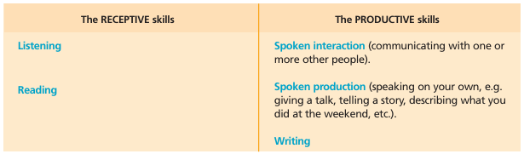

Silent(nonverbal) period:
During the early stages of language learning or language acquisition some children may go through a silent period. They may not talk but they still can communicate e.g. physically turning to each other to attract attention, bringing, holding objects to show comprehension, or using facial expression. A silent phase is common in language learning and does not necessarily indicate a learning problem. It is at this stage of language learning that children should be allowed to code-switch (use words or parts of sentences in the language(s) of the home). Good development in any second language (English/Irish) in the classroom normally involves code-switching as learners.

Resources:
- Up and Away programme by IILT
- Primary School Assessment Kit
- Toolkit for diversity
- Oide EAL padlet
- Dual language books
- Photos
- Visual timetables/ flashcards/puppets
- ICT/Digital Tools
- Songs/chants/rhymes/traditional stories
- Primary language curriculum
- New primary maths curriculum
- This list is not prescriptive or exhaustive and teachers may use additional resources for the planning and delivery of this programme.

Standardised testing:
In reference to Circular 0138 / 2006: “Pupils may be excluded from the test if in the view of the school principal they have learning or physical disability which would prevent them from attempting the test, or in the case of newcomer pupils, where their level of English is such that attempting such a test would be inappropriate.”
It is generally accepted that pupils who have not reached level A1.3 of the language proficiency benchmarks may not be tested with standardised tests

Whole school measures to ensure successful integration of EAL pupils:

At St Joseph’s National school all children are valued equally.

The school ensures:

- The delivery of an intercultural education to all pupils which is cross curricular and which permeates the ethos of the school
- The provision of books that give a world view from a variety of perspectives that portray characters from different ethnic backgrounds, there are a number of dual language books in our library.
- The affirmation of the languages and cultures which our eal pupils bring with them
- The awareness of children’s national days e.g.; Ramadan/Chinese New Year
- Development of intercultural activities. Inviting parents /children to talk to the classes about their cultures, music dances, songs, foods etc
- Inviting parents to partake in coffee mornings where they can exchange ideas and experiences
- Parent/toddler group for parents and children to socialise
- In school English classes
- Where feasible provide a translation service for parents

Young Interpreters:

- Our Young Interpreters are a team of children who support their peers with language learning. Informally, newly-arrived children are paired with children in their class who speak the same language and act as a guide and friend for their first few days, explaining routines and helping them find their feet. Many children remember their first few days and are keen to help out new children.
- Older children are matched with children in the younger classes who speak their language, over a longer period of time. The children meet together and spend time getting to know one another, talking about their experience at school, sharing stories and developing vocabulary in their home language and in English too. The Young Interpreters team meet with EAL teachers to share ideas and identify any issues and play an important role in language promotion across the school.

Reference Section:

- Circular 15/2009 Meeting the needs of pupils learning English as an Additional Language, DES
- Intercultural Education in the Primary School, Guidelines for schools, NCCA, 2005
- Primary School Assessment Kit, DES, 2007
- Toolkit for Diversity in the Primary School, 2007
- Up and Away, IILT, 2006
- Intercultural Guidelines for Schools, INTO
- Circular 138/2006 Supporting Assessment in the Primary School, DES
- Circular 0011/2024
- Meeting Additional Language Needs: Whole School and Classroom approaches for Inclusive language learning: Inspectors report February 2024

Success Criteria
- Pupils gradually gain access to the curriculum by becoming more proficient in English as an additional language.
- Pupils are enabled to grow in confidence. secure in their knowledge of the social norms of the school community, which is inclusive and intercultural.
- Pupils progress in their level of language proficiency in listening, speaking, reading and writing of the English language as per the Primary School Assessment Kit.
Ratification:
This policy has been discussed and accepted unanimously at a Management meeting on
2026

Brian Fitzgerald Denis Waters
Principal Chairperson BOM

Facts about Bilingual learners and good practice
Facts | Good Practice
Bilingual learners learn most English through interaction with other children | Group the EAL learners with supportive children who are good language models: through “talking partner” sessions. Change groups to support social cohesion.
English is best learned ……  through normal classroom activities, where there is a real need to communicate with native speakers | Involve the learner in collaborative group activities, where they can listen to English being used by other pupils and adults, and build up their confidence to use it.
Learning a second language is different to learning a first language because the learner has already learned at least one language and will use that knowledge in learning another language | Become familiar about the language background of the pupils, so that you have some idea of what prior knowledge the EAL learner is bringing to the learning of English eg, previous schooling.
Many beginners go through a “silent period” where they are listening, nut not yet confident enough to speak- this is a normal part of the process. | Involve the learner in non - verbal activities. e.g. Giving out books, doing a job, going with a note to a different classroom
Continuing support in the home language supports language learning and conceptual understanding – good home language skills can accelerate English skills | Make use of the learner’s home language in the classroom and support room. Encourage parents to continue with their child’s first language development. Use dual – language resources
Younger EAL learners usually learn in this order: listening, understanding, speaking, reading and writing. However, some older pupils will move into English through literacy rather than oracy. | Encourage young learners to base their literacy skills on underlying oracy skills. Early reading should be based on meaningful words and sentences.
It takes about two years to develop “social fluency” (BICS), but between 5 to 9 years to develop full “academic language proficiency” (CALP) | Make sure all EAL learners are appropriately challenges and supported depending on level of proficiency.
EAL learners benefit greatly from visual aids | Illustrate your teaching by using a variety of diagrams, visual timetables, pictures, real objects etc.
EAL learners need lots of opportunities to listen to and practice a new language:  Repetition of words, phrases, language structures helps the learner. | Plan for “Talk” as part of the lesson, giving opportunities for oral redrafting.  Repeat words and structure. Provide scaffolding for EAL learners.
EAL learners may find jokes and idioms hard to understand. | Be prepared to explain and find ways to express the meaning in other words
EAL learners need lots of praise and encouragement. | Show empathy and always encourage.
EAL learners need time to respond to your questions- especially if they are mentally translating. | Find ways to practise in pairs before to whole class.
The emphasis is on communication, not grammatical correctness. | Never explicitly correct, just model the correct sentence structure back

Scaffolding Strategies for EAL Learners:
Scaffolding the language of the curriculum so all learners can participate. Using scaffolds like sentence stems, sentence frames, graphic organisers, etc, learners can develop their English vocabularies in context and attain an understanding of the structure, semantics, syntax, and grammar of English in context, rather than just learning vocabulary in isolation.

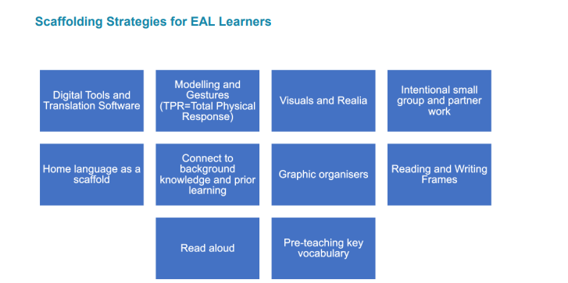

Primary Language Curriculum:
The Primary Language Curriculum reflects the linguistic and cultural diversity visible in Primary schools and supports all learners in their language and learning development.
Children develop concepts, dispositions and skills in relation to:
• Oral language: sentence structure and grammar, acquisition and use of vocabulary, comprehension, requests and questions, retelling and elaborating
• Reading: comprehension
• Writing: vocabulary

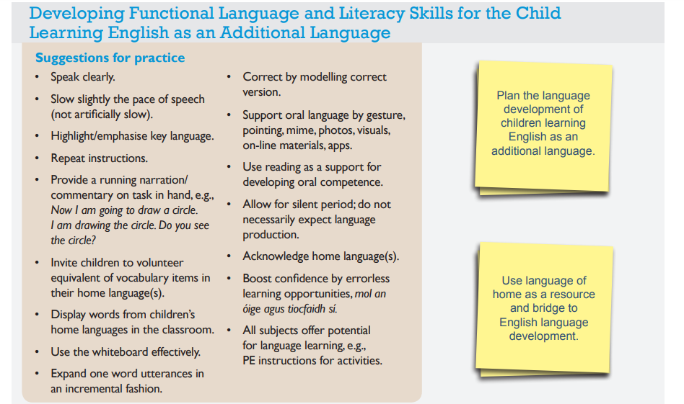

Language functions and language structures for EAL teaching:
Function | Question | Structures Needed
Naming: what someone or something is called | - What is this?  - What does it look like?  - What is it called?  - What is the name of this?  - What is she doing? | - This is a……  - It is a…..  - This is called….  - This is a….  - She is walking/running/eating
Identifying: Ability | - Can you……?  - Are you able to?  - Is it possible for….? | - I can swim, Ride my bike  - Dogs cannot fly, I cannot fly  - Birds can fly  - Fish can swim
Classifying:  Saying why things go together: | - Which of these go together?  - Why?  - How are they alike/similar?  - How can you compare x and y?  - Can you find another way to? | - These go together because  - These are the same/different  - This group is the same because….
Comparing;  Saying how something compares to something else | - Is x longer/shorter more/less than y  - Which is the longest/shortest/most/least?  - How much longer is it? | - X is longer/shorter than y  - Z is the longest, shortest/least/most  - Much longer/a little longer
Giving and following instructions | - What do you do first?  - What do you do now?  - How do you do this?  - Where do you put this? | - First put,  - Then cut….  - After that glue….  - Fold the paper  - When you hear the bell line up  - Place your counter on the red square
Describing; saying what something is like | - What is x like?  - What can you see?  - What did you notice about?  - How would you describe? | - It is red. It is big.  - It smells nice. It is scary  - This is a hard/difficult sum  - She has got black hair  - He looks like my dad  - She is tall/short/younger than me
Function | Questions | Structures Needed
Questioning;  Inquiring about something | How can? What do you think about?  What would happen if?  Can I ? | Please can I have a…  Can I have…  Can I do this
Evaluating  Reflecting on what you have done | Do you think this is a good thing?  How do you feel about this?  How could you improve this?  Is this the best way?  Is there anything you would have done differently ? | I really liked the part..  It would be better if…This worked well  It would have been better if,,,,
Expressing opinion | What do you think ? | I think that..,.
Locating:  Saying where something is or where it is going | Where is the bird?  Where is the cat going? | In /on/near the trees  It is running towards…  The cat is going behind the tree
Explaining:  Saying why things happen or happened | Why does?  How do you?  Why did this happen?  Why do you think that/?  Can you think of another reason?  Can you explain why...? | This happens because,,  The reason for this is..
Hypothesising predicting and reasoning :  Suggesting what happened/could happen/why it happened | What are you going to see at...?  What would/might happen if/  What would it be like If? | It might/would/could  I predict that  It will….
Reporting:  Saying what happened | What happened? Why?  What was the next thing you did? | I went/saw/give/because
Recalling | How many?  Where is?  What did we do last time?  Do you remember when? | I remember when  In my country we  In my old school/class we..  We did this the last time
Sequencing | What would you do first? | First/next/after that/then/finally
inferring | What do you think might happen?  How do you think they are feeling? | I think that this will happen  I think they are sad because
Observing | What can you tell me from the picture?  Tell me what can you see? | I see a…  In the picture the children are….
Expressing Preference | Which one would you prefer/like best? | My favourite….is  I like this one the best
Apologising | Can you say sorry? | I am sorry
Seeking assistance | What is the matter?  Are you okay?  Do you need help?  What is wrong? | I need help  Can you help me  I am sick  My head hurts  I have a sore leg
Refusing | Can I ask you to… | No I wont be able to../I can’t
Teaching Strategies and Pedagogical Approaches for EAL Learners:
Beginners have the right to be silent and may go through a “non-verbal” period for some time after arrival. Understanding and learning is still going on. Children are listening and storing information until such time as they feel confident in speaking aloud.
Collaborative Group Work: Pair or group EAL learners with able learning partners who are good language and behaviour models. Children are the best teachers
Identify key vocabulary and structures needed to engage with content of lesson
Target the key vocabulary and concepts that you want the EAL learner to focus on in the lesson eg, arm, bent, long short. Give them the opportunity to listen and use these words in context. The children learn and practise grammatical structures and sentence building using the topic vocabulary
Use mother tongue to support learning – bilingual reading books, dictionaries, talk partners
Use gestures and real objects to support meaning
Talk before writing. Speaking and listening is the starting point of a new topic or activity.

Model and repeat: instructions and key phrases and questions to increase familiarity
Identify culturally unfamiliar contexts by building on what is already known and providing visuals
Give key concepts, ideas and information in diagrammatic forms, graphic organisers or key visuals
Provide scaffolding for written activities e.g. true false sentences, sentence starters and endings, cloze text, labelling
Repeat key vocabulary with visual support. Give EAL pupils repeated opportunities ro use new vocabulary in context
Build in time for listening, understanding and practising vocabulary, allow EAL learners time to respond to questions
It is important that literacy support for EAL learners should not focus entirely on phonics. ‘The research is telling us that attention to phonics should not take place in isolation from activities that promote vocabulary building, meaning-making and comprehension’ (Edwards 2013).
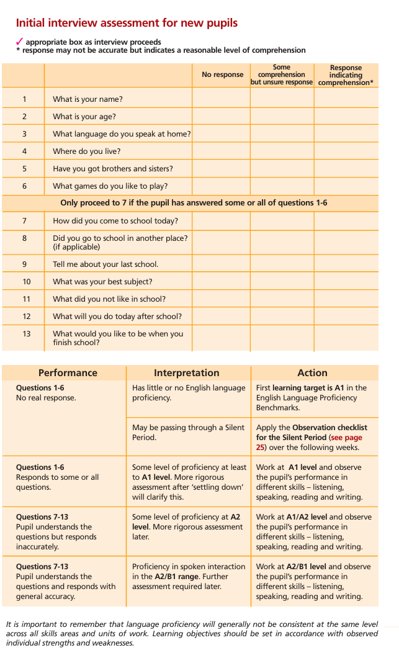
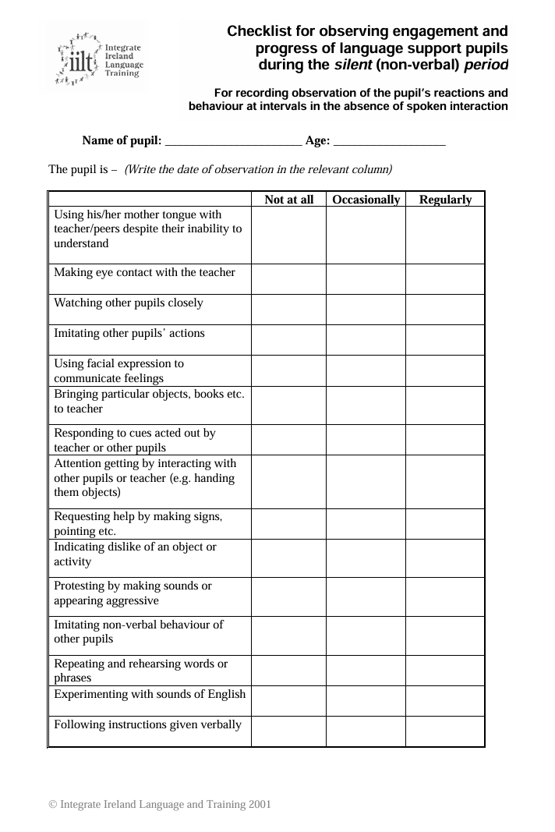
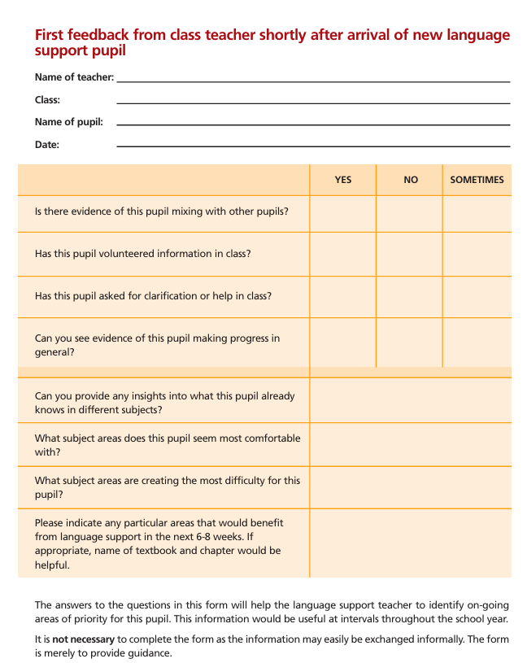

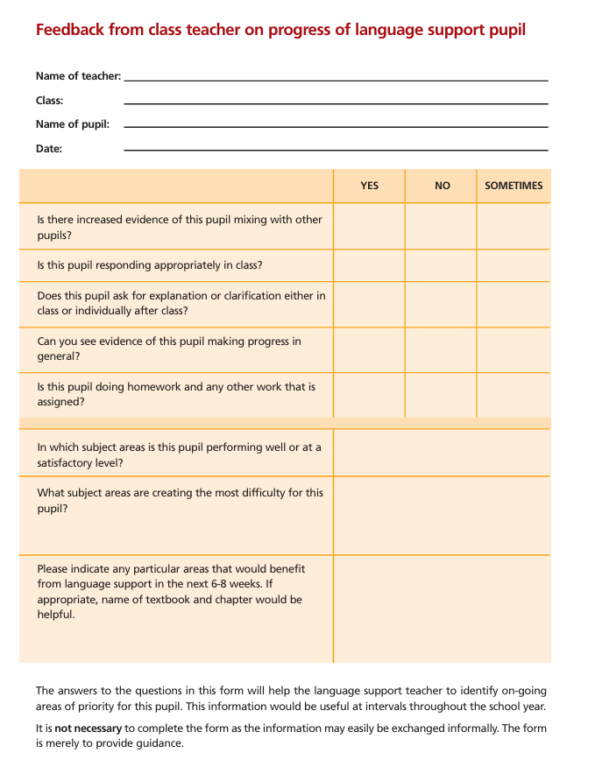

The 5-stage model of Language Acquisition:

A: New to English a child may:
Use first language for learning and other purposes
Remain silent in the classroom
Copy. Repeat some words and phrases
Understand some everyday English expressions but have minimal or no English literacy
Follow day to day social communication in English
Begin to use spoken English for social purposes
Understand simple instructions and follow narrative accounts with visual support
Develop some skills on reading and writing
Become familiar with some subject specific vocabulary

B: Early Acquisition:
Participate in learning activities with increasing independence
Express themselves orally in English but structural inaccuracies are still apparent
Requires ongoing support in literacy particularly for understanding text and writing
Follow abstract concepts and more complex written English
A child at this stage requires support to access the curriculum fully

C: Developing Competence
Developing oral English well, allowing successful engagement in activities across the curriculum
Read and understand a wide variety of text
Written English may lack complexity
Demonstrate evidence of errors in grammatical structure. A child at this stage needs support to access subtle nuances of meaning, to refine English usage, and to develop abstract vocabulary.
D: Competent
A child at this stage can operate across the curriculum to a level of competence nearing to that of a pupil who uses English as his/her first language. They may still make grammatical errors and need support to develop their linguistic skills

E: Fluent
A child at this stage can operate across the curriculum to a level of competence equivalent to that of a pupil who uses English as his/her first language

